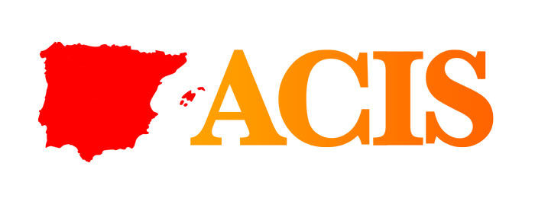
Wolfson Hall, Kelvin Conference Centre
University of Glasgow, 1 – 3 September 2011
Conference Programme

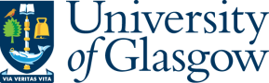 | 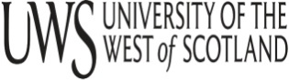 | 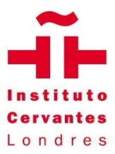  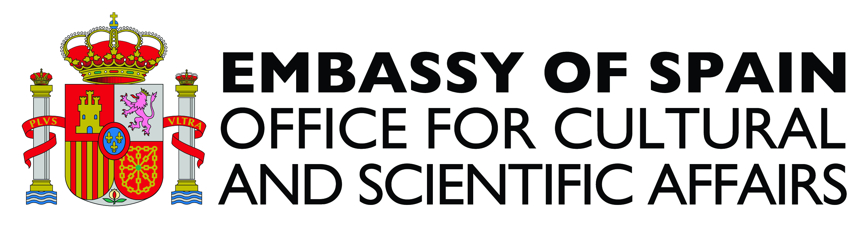

Thursday 1 September 2011
12.00 – 13.00 | Registration
12.30 – 13.30 | Lunch
13.45 – 14.00 | Welcome address
14.00 - 15. 00 | Plenary address  Chair: Lourdes Melcion  Willy Maley  University of Glasgow  “Far Distant, Far Distant: Scottish Volunteers in the Spanish Civil War”
15.00-15.30 | Coffee
15.30 – 17.30 | Panel sessions
Panel 1: INTERNATIONAL RELATIONS, EMPLOYMENT AND CITIZENSHIP  Chair: Margaret Anne Clarke  Gisela da Silva Guevara  University of Coimbra  Portuguese Geopolitics at the beginning of the twentieth century  Teresa Pinheiro  Institut für Europäische Studien  Technische Universität  The “museo d’historia” de la immigració de Catalunya  Rosa García-Orellan  Universidad Pública de Navarra  David Close  Memorial University, St John’s NL, Canada  Hard economic times and health policies in Galicia and the Basque Country: effects on health care professionals |  | Panel 2: LITERATURE, CONTEMPORARY WRITING AND ART  Chair: TBC  Margarida Rendeiro  CEPESE and Lusíada University  Mapping Lisbon through the eyes of Portuguese novelists after 1974: the Lisbon of Baptista-Bastos and José Cardoso Pires  Eduardo Barros Grela  Facultad de Zapateira, A Coruña  Esquizofrenias espaciales desde la poesia contemporânea  Ana Cristina Pires Cachola  Catholic University of Portugal  Warscapes, the figures and their absence: The war on terror in Portuguese contemporary art
17.45 – 18.45 Association for Contemporary Iberian Studies, Annual General Meeting
Friday 2 September 2011
9.00 - 11.00 Panel sessions
Panel 3: PERFORMANCE, GENDER AND STORYTELLING  Chair: Margaret Anne Clarke  Jennifer L. Romero  Universidad Autónoma de Madrid, Spain  De ahora en adelante: The ‘Transitional’ Stardom of Rocío Jurado  Karen Díaz Anchante  Washburn University, USA  Habitar el género: “Una mujer desnuda” de Lola Beccaria y la escritura de la sexualidad  Maria João Castro  Universidade Nova de Lisboa, Portugal  The Portugal That Danced: The Verde Gaio company and the creation of state propaganda and control under Salazar’s dictatorship  Luís Correia Carmelo  The storytelling revival in Portugal and Spain |  | Panel 4: COMMUNICATIONS, JOURNALISM AND MEDIA  Chair: Georgina Blakeley  Toni Sellas  Universitat Internacional de Catalunya, Spain  The Catalan News Agency: the public-owned platform to explain Catalonia abroad  Christopher Tulloch  Universitat Pompeu Fabra, Barcelona  Foreign Press Correspondents and the Spanish transition to Democracy  Rita Luís  Universitat Pompeu Fabra  The press and the Iberian democratic transition process  Charo Lacalle  Universitat Autonòma de Barcelona  Catarina Duff Burnay  Catholic University of Portugal  Iberian Market for Television Fiction: A Comparative analysis
11.00 -11.30 | Coffee
11.30 – 13.00 | Panel sessions
Panel 5: CULTURAL IDENTITY IN SPAIN, PORTUGAL AND CATALONIA  Chair: Jared Larson  John McCulloch  University of Glasgow, UK  Cultural Nomadism in 20th Century Spain  Danielle Cahill Velardi  Christopher Newport University, USA  “Ver y ser vistos en la Movida Madrileña”  Luis Gomes  University of Glasgow, UK  Identidade Cultural de Não-Espanha: em torno da política cultural do Estado Novo aos nossos dias |  | Panel 6: FILM  Chair: TBC  Miguel Olid  Independent Film Director  La censura contra el humor durante a ditadura de Franco: el caso de Eduardo Garcia Maroto  Francisco Javier Ruiz del Olmo  Universidad de Málaga  Contemporary documentary film practice in Spain: the case of Jose Luis Guerín  Gabrielle Carty  Dublin City University  Genre, Convention and Innovation in La Vida en un hilo, 1945, directed by Edgar Neville
13.00 - 14.00 | Lunch
14.00 – 16.00 | Panel sessions

Panel 7: IMAGINÁRIOS Y TRÁNSITOS EN LA HISTORIA Y LA MEMORIA AUDIOVISUAL ESPAÑOLA  Chair: TBC  Lorenzo Ayuso Fernández  Universidad Complutense de Madrid  Terrores del autor: trasvases e imaginarios entre el cine español de los setenta y su referente estadounidense  Amparo Guerra Gómez  Universidad Complutense de Madrid  Transferencias e imaginários del American dream en el cine popular español del desarrolismo a la transición  José Carlos Rueda Laffond y Belén Moreno Garrido  Universidad Complutense de Madrid  Un espacio simbólico en tránsito: Imaginario y memoria televisiva del Valle de los Caídos  Carlota Coronado Ruiz e Isabel Martin Sánchez  Universidad Complutense de Madrid  La España en tránsito: Imaginario y memoria televisiva del exilio |  | Panel 8: CHANGE, CONTESTATION AND THE STATE IN SPAIN AND PORTUGAL: RECONCILING THE PAST WITH THE PRESENT IN CONTEMPORARY IBERIA (2)  Chair: Fernando León-Solís  Luís Bernardo  Humboldt-Universität zu Berlin  Assertive, passive or non-secularist? Asserting religion policy in Portugal  Lluís Medir  Universitat de Barcelona  Local democracy in Catalonia: from formally institutionalised processes towards self-organised social referenda for independence  Georgina Blakeley  The Open University, UK  Necessary but Insufficient? Evaluating Spain’s Law of Historical Memory  Jared D. Larson  University of Delaware  Public opinion and the fear of contemporary immigration to Spain and Portugal: Measuring the perception of economic, security and cultural threats in Iberia
16.00 – 16.30 | Coffee
16.30 – 17.30 | Plenary Address  Use Lahoz  La novela actual como elemento de recuperación de la posguerra
18.45 | Bus departs for Vino de Honor and Conference Dinner
19.15 | Vino de Honor. Hilton Grosvenor Hotel.
20.00 | Conference Dinner. Hilton Grosvenor Hotel.
23.00 | Bus departs from Hilton Hotel to Wolfson Hall.

Saturday 3 September 2011
9.00 - 10.00 |  | Panel sessions
Panel 9: TELEVISION  Chair: TBC  Charo Lacalle  Universitat Autonònoma de Barcelona, Spain  The building of youth identities in Spanish television fiction  Rogerio Santos  Catholic University of Portugal  Twenty years of Portuguese commercial television |  | Panel 10: JOURNALISM  Chair: Georgina Blakeley  Sandra Tuna  Jorge Pedro Sousa  Fernando Pessoa University  The relationship between journalism and society as viewed by Portuguese journalists during the dictatorship (1933 – 1974): (responsible) journalism as public service  Tobias Reckling  University of Portsmouth  New Era in Spain: foreign correspondents and the perception of the Spanish transition to democracy
10.00 –11.00 |  | Panel sessions
Panel 11: ORAL HISTORY, MEMORY AND NEW MEDIA  Filomena Sousa  Memoria Imaterial  Instituto de Estudos de Literatura Tradicional  Universidade Nova de Lisboa  MEMORIAMEDIA Immaterial heritage Online - Portugal  Mark Gant  University of Chester, UK  “I would have come even if the boat had been made of paper”: from Senegal to Palma: migration and storytelling |  | Panel 12: TRANSLATION AND PEDAGOGY  Chair: TBC  Sandra Tuna  Elsa Simões Freitas  Fernando Pessoa University, Portugal  On the implications of non-translation in Portuguese advertising  Carmen Usategui  Developing reflection through group work and collaborative learning
11.00 – 11.30 | Coffee
12.30 – 13.30 | Plenary address  Martin Eaton  University of Ulster.  “Child workers and immigrants: a note on Portugal’s enduring labour market issues”
13.30 – 14.30 | Lunch

